

Smart Reconfigurable Test

Software Design Description

Author: Sean McMahon

Department: Software

Contributors:

**Most Marvellous Company Ltd.**

9 Inchicore Terrace North, Inchicore, Dublin 8, Ireland

[ww.mostmarv.com](http://mostmarv.com/)

# Data Item Description

## 

## Revision History

|  |  |  |  |  |
| --- | --- | --- | --- | --- |
| **Version** | **Status** | **Date** | **Author** | **Change Description** |
| 0.1 | Draft | 13/11/2019 | S McMahon | Initial draft |
| 0.2 | Draft |  |  | Document Review |
| 1.0 | Release |  |  |  |

## Purpose

Describe process of installing and running Smart Reconfigurable System project.

## Stakeholders

Stakeholder should indicate their approval.

|  |  |  |
| --- | --- | --- |
| **Position** | **Name** | **Date** |
| Project Owner | Garret O’Doherty |  |

# Contents

1. Data Item Description 2

Revision History 2

Purpose 2

Stakeholders 2

2. Mysql 4

# Mysql

Download from

<https://dev.mysql.com/downloads/installer/>

Windows (x86, 32-bit), MSI Installer 8.0.18 415.1M

Download

(mysql-installer-community-8.0.18.0.msi) MD5: 906b5f84343d487f716f03b5925d8286

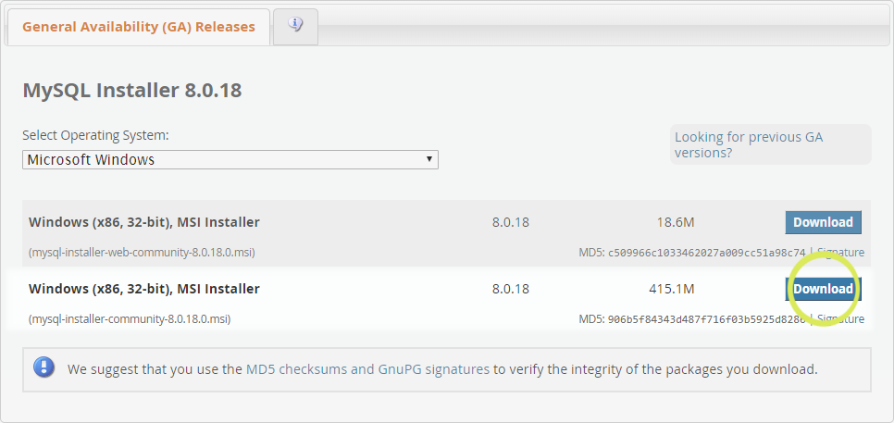

Install MySQL Server, Workbench and ODBC connector.

Add the following local user.

Username:

root

Password:

Tri,MMC,roo,

# Add database for demo project

Launch MySQL Workbench

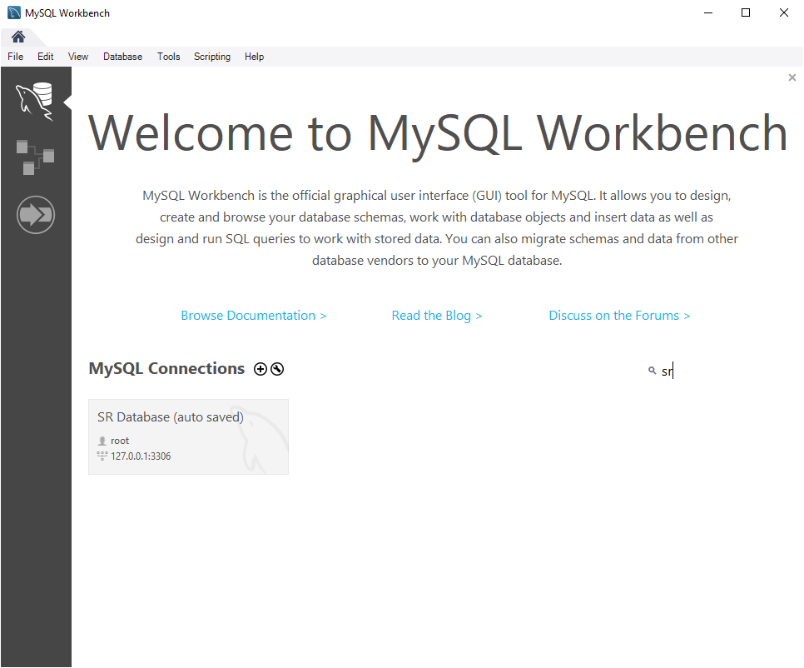

Figure 1 MySQL Workbench

Click the + button and enter the connection details as shown below:

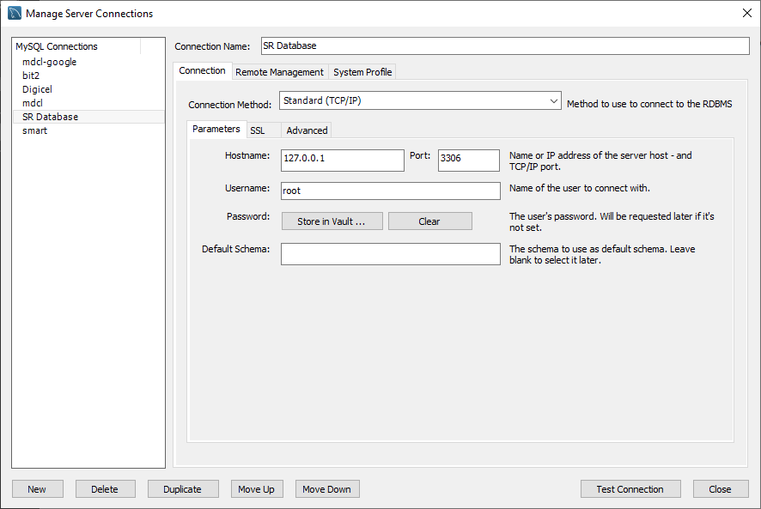

Figure 2 Connection details

Click test connection to display the follow popup:

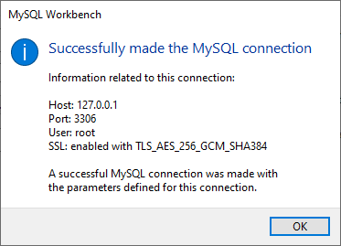

Figure 3 Connection success

Click close and then double click the new connection option on the landing page.

Copy and paste the following script in the Query window.

-- MySQL Workbench Forward Engineering

SET @OLD_UNIQUE_CHECKS=@@UNIQUE_CHECKS, UNIQUE_CHECKS=0;

SET @OLD_FOREIGN_KEY_CHECKS=@@FOREIGN_KEY_CHECKS, FOREIGN_KEY_CHECKS=0;

SET @OLD_SQL_MODE=@@SQL_MODE, SQL_MODE='TRADITIONAL,ALLOW_INVALID_DATES';

-- -----------------------------------------------------

-- Schema mydb

-- -----------------------------------------------------

-- -----------------------------------------------------

-- Schema led

-- -----------------------------------------------------

-- -----------------------------------------------------

-- Schema led

-- -----------------------------------------------------

CREATE SCHEMA IF NOT EXISTS `led` DEFAULT CHARACTER SET utf8mb4 COLLATE utf8mb4_0900_ai_ci ;

USE `led` ;

-- -----------------------------------------------------

-- Table `led`.`users`

-- -----------------------------------------------------

CREATE TABLE IF NOT EXISTS `led`.`users` (

`username` VARCHAR(10) NOT NULL,

`password` VARCHAR(45) NULL DEFAULT NULL,

`role` VARCHAR(45) NULL DEFAULT NULL,

PRIMARY KEY (`username`))

ENGINE = InnoDB

DEFAULT CHARACTER SET = utf8mb4

COLLATE = utf8mb4_0900_ai_ci;

SET SQL_MODE=@OLD_SQL_MODE;

SET FOREIGN_KEY_CHECKS=@OLD_FOREIGN_KEY_CHECKS;

SET UNIQUE_CHECKS=@OLD_UNIQUE_CHECKS;

Click the execute (lightning symbol) button.

# Add Admin User

Next a user needs to be added.

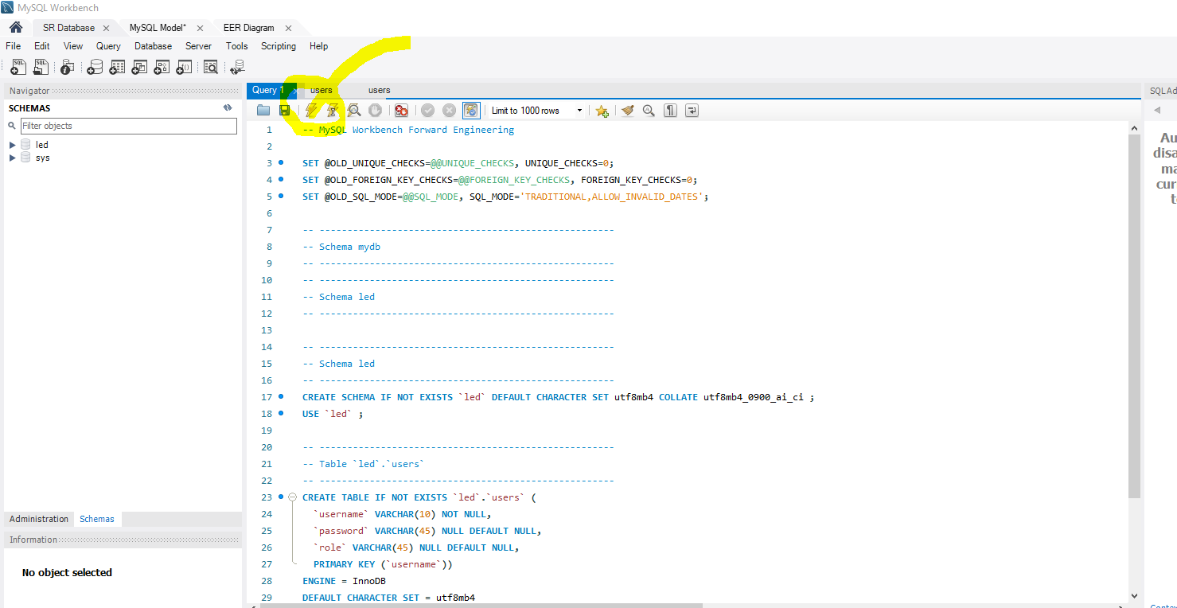

Figure 4 execute script

Add an admin user

INSERT INTO `led`.`users` (`username`, `password`, `role`) VALUES ('admin', 'admin1', 'admin');

There is now a database with a table called user and an admin entry. This demonstrates LCOD in the reconfigurable portion of the code.

# Git

The code is available on GitHub and can be accessed with the username/ password provided by MMC.

An easy way of managing the code is with github for desktop, (<https://desktop.github.com/>). Download, install and sync with the private project repository (<https://github.com/seanjmcm/Trinity>)

# SRS Launch

The project is significantly advanced given the short development time of just over 2 days. The project demonstrates the proposed LCOD based Smart Reconfigurable architecture.

It is exciting to see it operational!

To launch, first open the project : SR System.lvproj then launch SR Test Launcher.vi

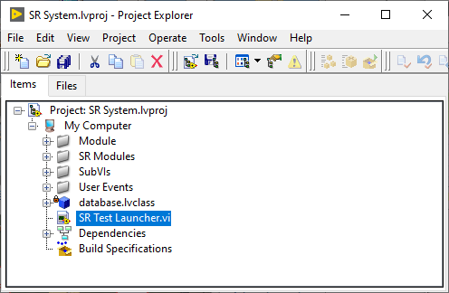

Figure 5 LabVIEW Project

Once launched click the run button to view the project.

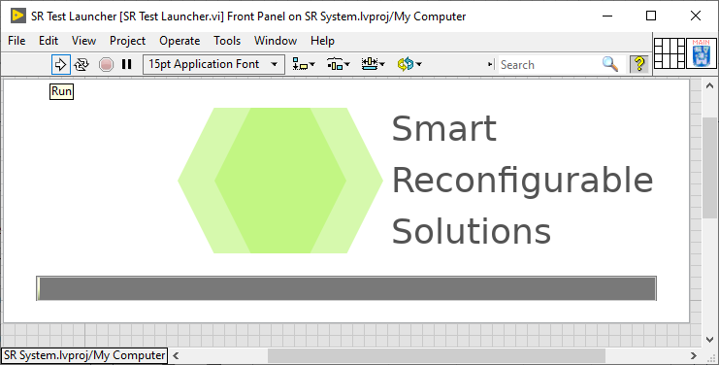

Figure 6 SR Test Launcher

The settings can be accessed and altered in the setting folder.

[TestPlan]

Current Consumption = "TRUE"

Emission Spectrum = "TRUE"

[Instruments]

Resistor 1 = "1600.000000"

Resistor 2 = "390.000000"

Resistor 3 = "190.000000"

[Limits]

Current 1 = "5.000000"

Current 2 = "20.000000"

Current 3 = "40.000000"

Tolerance = "10.000000"

Wavelength = "640.000000"

[Settings]

VLED 1 = "2.000000"

VLED 2 = "2.200000"

VLED 3 = "2.400000"

Source V = "10.000000"

Result Path = "/c/temp"

# Addendum

These are exciting first steps on the road to a full featured reconfigurable system.

It is not possible to complete such a vision in three days but with further and a focus on a particular sector, this vision when realised could become a leader in the sector and yield significant revenue for a company that were to market and sell this product.